- Friday morning's sell-off highlighted the fragile market confidence in the UK government's fiscal approach. We previously outlined a scenario where markets react strongly to the Budget, causing sterling to depreciate significantly and gilt yields to rise. This week's events follow the blueprint of that scenario.
- This scenario would add to the UK's inflation problem and reduce the scope for the Monetary Policy Committee to cut interest rates. The Budget and next two inflation releases will be the key influences on December's MPC meeting and could prevent a rate cut, despite evidence of renewed weakness in the activity and labour market data.
A week of government communications fiascos culminated in the 10-year gilt yield rising 11bps in early trading on Friday. Problems earlier in the week focused on the Prime Minister's team briefing against a senior minister with leadership ambitions. Friday's moves revolved around speculation about the Budget contents. On Monday, Chancellor Rachel Reeves was interviewed by the BBC and offered the strongest hint yet that she planned to abandon the Labour party's election manifesto pledge and increase income tax. However, rumours circulated on Friday that the Chancellor had asked the Office for Budget Responsibility to remove the income tax hike from its latest forecast.
This episode demonstrates the importance of the Budget as a test of market confidence in the UK government's fiscal approach. Friday's story could turn out to be untrue. If the government has done a volte-face, it would be a risky strategy. If the cause is political, with the government concerned about how voters will react to income tax hikes, it may strengthen perceptions that the government lacks the appetite to take tough fiscal decisions. If it reflects favourable OBR forecast revisions, there's a risk markets question the credibility of those projections.
In a recent note we outlined a scenario where the government missteps and markets take fright. We anticipate this leading to a sharp depreciation of sterling, along with rising gilt yields. This week's events follow the blueprint of that scenario.
Chart 1: There's been a marked loss of momentum in private sector regular pay growth
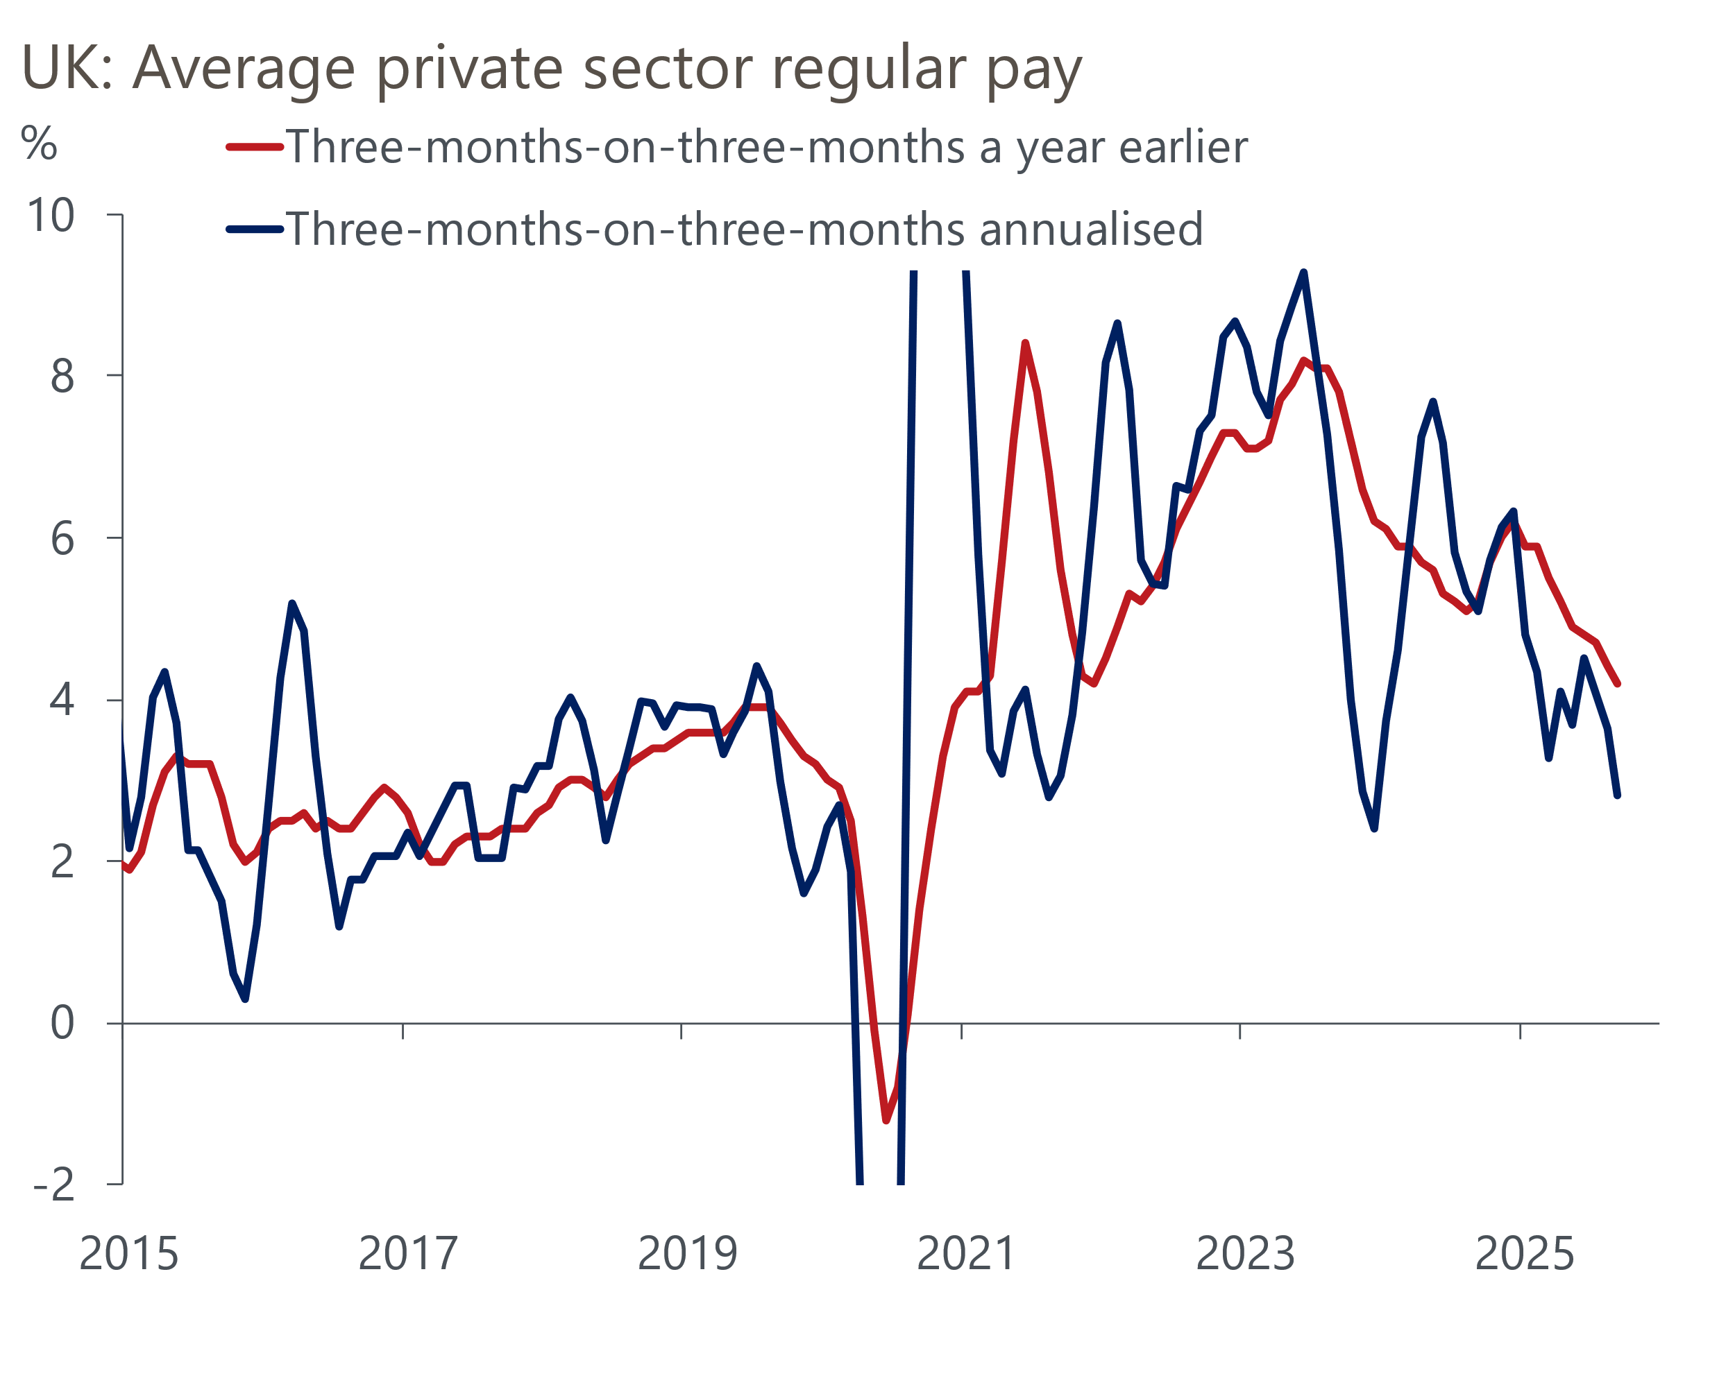
Source: Haver Analytics

This scenario would limit the Monetary Policy Committee's ability to reduce interest rates. Before Friday's events, the week's data indicated the MPC's recent dovish tilt was prescient.
Tuesday's labour market release was weak overall. Private sector regular pay, closely monitored by the Bank of England, showed the weakest y/y growth in almost five years in September. Some of the downward pressure stemmed from strong base effects, but the three-months-on-three months annualised rate indicates a clear loss of momentum (Chart 1).
Alongside cooling pay growth, labour market conditions are gradually loosening. We pay little regard to the Labour Force Survey data due to ongoing low response rates. HMRC's count of payrolled employees fell in both September and October, indicating renewed weakness after headcount stabilised in the summer. Previously strong job creation in the public sector had offset job losses in the private sector, but that support now appears to be waning. HMRC's measure has its own issues, particularly the tendency for initial estimates to be revised up. But workers appear set to enter the key new year pay review period in a weaker bargaining position than in recent years.
Activity data also disappointed as GDP fell 0.1% m/m in September, after being flat in August. This resulted in output growing by only 0.1% q/q in Q3, a significant drop from the previous two quarters. However, there are two reasons why we're relatively sanguine about the recent trajectory of the data.
First, 2025 has followed the well-established pattern of the past few years where a strong Q1 is followed by a loss of momentum in the middle of the year. This pattern likely stems from residual seasonality in the data, which exaggerates the extent of the apparent slowdown (Chart 2). Second, September's fall in GDP was entirely due to a 2% m/m drop in industrial production. While all four sub-sectors experienced reduced output, the primary cause was a 28.6% decrease in the motor vehicles sector. The Office for National Statistics said this decline was largely due to a major motor manufacturer halting production due to a cyber-attack. With production now resumed, output is expected to recover in Q4.
Chart 2: GDP data continues to show residual seasonality, with strong starts to the year quickly fading
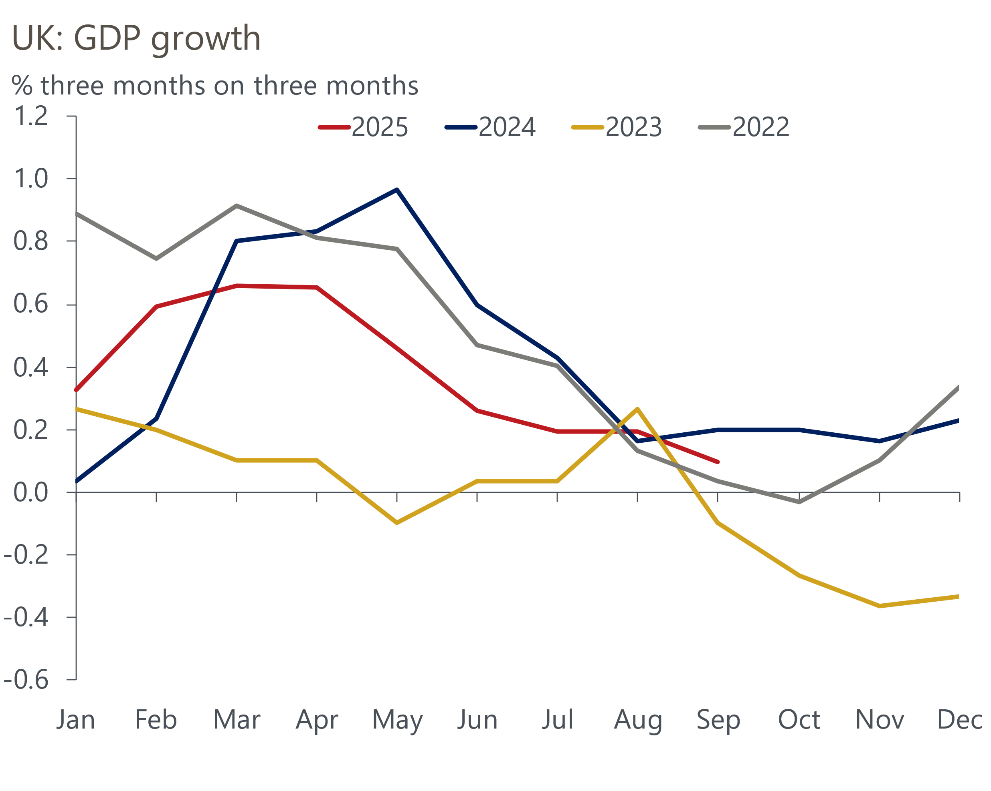
Source: Haver Analytics
But taking a step back, it's evident that underlying momentum remains sluggish. The expenditure breakdown for Q3 provided a good explanation of why the economy's performance has underwhelmed, with key parts of the economy continuing to struggle. Consumer spending growth was soft, despite the recent strength in retail sales, while business investment declined again.
Financial markets interpreted this week's data as supporting a December rate cut, with Thursday's pricing implying an 81% chance that the MPC will cut, up from 68% in the aftermath of the November meeting. Given the deep divide on the committee, this probably overestimated the probability. The contents of the Budget and the next two inflation outturns were always likely to have a more decisive impact on the MPC's December interest rate decision than this week's two major releases. If the government can deliver a large and credible fiscal tightening that convinces markets, then a December cut will remain on track. However, that outcome seems less likely than it did yesterday.

The week ahead
October's inflation release is likely to mark the beginning of a gradual easing in price pressures. The contribution of the energy sector to inflation will fall by a little over 0.2ppts, with this year's October increase in the energy price cap being much smaller than last year's. Though there will be some mitigation from higher petrol prices, with the base effects running in the opposite direction to energy, we expect CPI inflation to fall to 3.6% from 3.8% in September.
Retail sales have grown by 0.5% m/m or more in each of the last three months, leaving the level of sales well above the levels seen earlier this year. The non-food and the non-store sectors look particularly frothy, particularly in the context of other much softer consumer indicators, so we think the sales data is ripe for some payback soon. We pencil in a 0.6% m/m fall in sales in October.
The PMIs picked up in October but were still well down on the levels seen earlier in the year. The results have been heavily affected by swings in sentiment related to the newsflow. With the Budget looming on the horizon and widespread speculation about tax rises, we think the flash S&P Global survey will show the composite PMI dropping back to 51.5 in November.
Table 1: Week ahead calendar
Date | Events | Period | Measure | Unit | Previous | Forecast
Nov 19 | CPI inflation | Oct | m/m | % | 0.0 | 0.4
Nov 19 | CPI inflation | Oct | y/y | % | 3.8 | 3.6
Nov 19 | RPI inflation | Oct | m/m | % | -0.4 | 0.3
Nov 19 | RPI inflation | Oct | y/y | % | 4.5 | 4.3
Nov 19 | Producer input prices | Oct | m/m | % | -0.1 | 0.1
Nov 19 | Producer input prices | Oct | y/y | % | 0.8 | 0.9
Nov 19 | Producer output prices | Oct | m/m | % | 0.0 | 0.2
Nov 19 | Producer output prices | Oct | y/y | % | 3.4 | 3.7
Nov 19 | Land Registry house prices | Sep | y/y | % | 3.0 | 3.0
Nov 21 | GfK consumer confidence | Nov | Headline | % bal | -17 | -17
Nov 21 | Retail sales inc fuel | Oct | m/m | % | 0.5 | -0.6
Nov 21 | Retail sales inc fuel | Oct | y/y | % | 1.5 | 1.4
Nov 21 | Public finances | Oct | PSNB ex | £bn | 20.2 | 15.0
Nov 21 | S&P Global manufacturing | Nov | PMI | % bal | 49.7 | 49.0
Nov 21 | S&P Global services | Nov | PMI | % bal | 52.3 | 51.6
Nov 21 | S&P Global composite | Nov | PMI | % bal | 52.2 | 51.5
Source: Oxford Economics

Key forecasts
Table 2: UK forecast overview
(Annual percentage changes unless specified)
 | 2023 | 2024 | 2025 | 2026 | 2027 | 2028
GDP | 0.3 | 1.1 | 1.5 | 0.9 | 1.3 | 1.7
Private consumption | -0.3 | -0.2 | 1.0 | 1.1 | 1.1 | 1.7
Fixed investment | 0.5 | 1.8 | 2.1 | 0.5 | 1.5 | 2.0
Government consumption | 2.1 | 3.4 | 2.1 | 1.7 | 1.6 | 1.7
Exports of goods and services | -2.3 | 0.6 | 3.0 | 0.2 | 1.2 | 1.5
Imports of goods and services | -1.6 | 2.6 | 3.9 | -0.5 | 1.2 | 1.5
Industrial production | -2.6 | -1.6 | -0.3 | -0.1 | 1.1 | 1.3
Consumer prices | 7.3 | 2.5 | 3.4 | 2.8 | 2.5 | 2.2
Unemployment rate (%) | 4.1 | 4.3 | 4.7 | 4.9 | 4.8 | 4.4
Current a/c balance (% of GDP) | -3.6 | -2.2 | -3.1 | -2.6 | -2.4 | -2.3
Government balance (% of GDP) | 5.2 | 5.2 | 4.8 | 3.5 | 3.1 | 2.7
Central bank policy rate (%, EOP) | 5.25 | 4.75 | 3.75 | 3.25 | 3.00 | 2.75
10yr govt. bond yield (%, EOP) | 3.54 | 4.57 | 4.60 | 4.24 | 3.76 | 3.48
Exchange rate (US$ per £, EOP) | 1.27 | 1.25 | 1.29 | 1.29 | 1.29 | 1.29
Exchange rate (euro per £, EOP) | 1.15 | 1.21 | 1.11 | 1.11 | 1.11 | 1.11
Source: Oxford Economics
Table 3: Quarterly forecasts for the UK
 | 2025 |  |  |  | 2026
 | Q1 | Q2 | Q3 | Q4 | Q1 | Q2 | Q3 | Q4
GDP (% year) | 1.7 | 1.4 | 1.4 | 1.3 | 0.9 | 0.9 | 0.9 | 1.0
CPI inflation (% year) | 2.8 | 3.5 | 3.8 | 3.6 | 3.3 | 2.5 | 2.7 | 2.6
Bank Rate (%, EOP) | 4.50 | 4.25 | 4.00 | 3.75 | 3.75 | 3.50 | 3.50 | 3.25
10yr gilt yield (%, EOP) | 4.70 | 4.48 | 4.70 | 4.60 | 4.57 | 4.49 | 4.38 | 4.24
US$ per £ (EOP) | 1.29 | 1.37 | 1.35 | 1.29 | 1.29 | 1.29 | 1.29 | 1.29
Euro per £ (EOP) | 1.20 | 1.17 | 1.15 | 1.11 | 1.11 | 1.11 | 1.11 | 1.11
Source: Oxford Economics

Latest Country Economic Forecast:
October 13, 2025

Recent publications

Data Insights
GDP fell in September, as industrial production slumped
Weak labour market release supports case for more rate cuts
Services sector shows few signs of Budget fears
October's stronger manufacturing PMI is unlikely to be sustained
Mortgage activity has stabilised after distortions earlier this year

Research Briefings
Dovish hold in November puts a December rate cut in play
MPC preview – softer data unlikely to herald November cut
What should the Chancellor do in the Budget?
What happens if markets lose faith in the fiscal approach?
What will the Chancellor do in the Budget?

Contacts

Oxford Economics' UK team
- Andrew Goodwin - Chief UK Economist - agoodwin@oxfordeconomics.com
- Edward Allenby - Senior UK Economist - eallenby@oxfordeconomics.com

